Effectiveness of Monetary Policy Transmission in India: An Econometric Analysis of Repo Rate, Bank Lending Rates, and Inflation.

A Project report submitted for partial fulfillment of the Degree of Bachelor of Science


School of Statistics
Devi Ahilya Vishwavidyalaya, Indore Session (2023-26)

GUIDED BY SUMITTED BY
Dr. Arpita Lakhre Tushar Dey
Asst. Professor Roll No. ST4A2305
School of Statistics

FORWARD

I feel immense pleasure to forward the project entitled “Effectiveness of Monetary Policy Transmission in India: An Econometric Analysis of Repo Rate, Bank Lending Rates, and Inflation.” submitted by Tushar Dey (V semester) for fulfilment of the requirements for the degree Bachelor of Science (Hons.) in Applied Statistics and Analytics at the School of Statistics, DAVV, Indore.

Dr. Ganeswar Mishra
Head
School of Statistics DAVV, Indore (M.P.)

CERTIFICATE

The research work embodied in the present project entitled “Effectiveness of Monetary Policy Transmission in India: An Econometric Analysis of Repo Rate, Bank Lending Rates, and Inflation” has been carried out in the supervision of Dr. Arpita Lakhre. The work reported herein is original and does not form part of any other report or dissertation based on which a degree or award was conferred on an earlier or to any other scholar. I understand the University’s policy on plagiarism and declare that the project and publications are my own work, expect where specifically acknowledged as has not been copied from other sources or been previously submitted for award of assessment.

Dr. Arpita Lakhre Dr. Ganeswar Mishra
Asst. Professor Head
School of Statistics School of Statistics
DAVV, Indore DAVV, Indore

ACKNOWLEDGEMENT

I would like to express my sincere gratitude to everyone who contributed to the successful completion of this project. Your support and encouragement played a crucial role in making this endeavor a reality.
First and foremost, I am immensely thankful to my advisor, Dr. Arpita Lakhre, for their invaluable guidance and continuous support throughout the entire project. Their expertise and insightful feedback greatly enriched the quality of my work.
I extend my appreciation to my colleagues and peers who provided assistance and shared their knowledge during the various stages of the project. The collaborative spirit within the team contributed significantly to the overall success of the project.
I am grateful to Devi Ahilya Vishwavidyalaya for providing the necessary resources and infrastructure that facilitated the smooth progress of the project
Special thanks go to my friends and family for their unwavering support and understanding during the demanding phases of the project. Their encouragement kept me motivated and focused, even in challenging times.
Lastly, I want to acknowledge the participants and respondents who generously contributed their time and insights, making this project more comprehensive and meaningful.

Thank you to everyone who played a part, no matter how big or small, in bringing this project to fruition.

Tushar Dey

DECLARATION

I, Tushar Dey, a student of B.Sc.(Hons) Applied Statistics & Analytics at the School of Statistics, Devi Ahilya Vishwavidyalaya, declare that the project report titled " Effectiveness of Monetary Policy Transmission in India: An Econometric Analysis of Repo Rate, Bank Lending Rates, and Inflation. " is my original work under the guidance of Dr. Arpita Lakhre.
I affirm that this project has not been submitted elsewhere for any other degree or diploma, and the sources of information used in this report have been duly acknowledged. Any contribution from other individuals or sources has been appropriately credited.
I also declare that the project work complies with the academic standards and guidelines provided by the university. The data, analysis, and conclusions presented in this report are authentic and reflect my efforts in exploring the topic.
I understand the consequences of providing false information and plagiarism, and I take full responsibility for the content presented in this project report.

Date:
Tushar Dey
ST4A-2305

Contents

Abstract
Introduction
Problems and Motivation
Purpose of the study
Research Question:
Significance of the Study:
Review of Related Literature
Monetary Policy Transmission Mechanism
Interest Rate Channel
Repo Rate and Bank Lending Rates
Lagged Effects and Dynamic Adjustment
Interest Rates and Inflation
Econometric Modeling and Forecasting
Methodology
Data and Sources
Variable Definition
Econometric Models
Hypothesis Testing
Estimation Technique
Forecasting and Scenario Analysis
Data Visualization
Limitations
Conceptual Paradigm
Data Visualization
Trend Chart Policy Repo rate:
Trend Chart Weighted Average Lending Rate (WALR)
CPI Inflation Rate Chart
Weighted Average Lending Rate vs Repo rate
Approach
DATABASE
Regression Analysis
Repo Rate and WALR (Contemporaneous Model)
- Key Points and Findings
Lagged Repo Rate and WALR (Delayed Transmission Model)
- Key Points and Findings
Current and Lagged Repo Rates with WALR (Dynamic Model)
- Key Points and Findings
Lagged WALR and Inflation (Price Transmission Model)
- Key Points and Findings
Overall Results of the Study
Limitations of the Study
Future Scope of the Study
Conclusion
Appendix
DATASETS
Bibliography

Effectiveness of Monetary Policy Transmission in India: An Econometric Analysis of Repo Rate, Bank Lending Rates, and Inflation

Abstract:
This study empirically examines the monetary policy transmission mechanism in India using time-series econometric analysis and data visualization techniques implemented in Microsoft Excel. The analysis focuses on the interest rate channel, tracing the transmission of changes in the Reserve Bank of India’s (RBI) policy repo rate to bank lending rates and subsequently to inflation. Monthly data on the repo rate, weighted average lending rate (WALR), and Consumer Price Index (CPI)–based inflation are employed, covering a recent post-2014 period to capture contemporary monetary policy dynamics.
The empirical methodology consists of a sequence of regression models incorporating both contemporaneous and lagged variables to account for delayed transmission effects. Initially, simple linear regressions establish a strong and statistically significant relationship between the repo rate and WALR, indicating effective and more-than-proportional pass-through from policy rates to lending rates. Lagged regressions further confirm that repo rate changes exert persistent effects on lending rates, reflecting gradual adjustment by banks. A multivariate regression model including both current and lagged repo rates demonstrates that monetary transmission is predominantly contemporaneous, with a smaller but statistically significant delayed component, highlighting the presence of interest rate smoothing and short-term adjustment frictions.
The analysis is extended to inflation dynamics by estimating a lagged regression of CPI inflation on WALR. The results reveal a statistically significant and negative relationship, confirming that higher lending rates reduce inflation with a lag, consistent with the demand-side channel of monetary policy. Although the explanatory power of the inflation model is modest, this outcome is expected given the influence of supply-side factors and external shocks on inflation in the Indian economy.
Finally, the study conducts short-term forecasting exercises for lending rates and inflation under the assumption of an unchanged policy rate, as well as alternative monetary policy scenarios. The forecast results suggest that lending rates stabilize in the absence of policy changes, while inflation responds gradually to past interest rate movements. Overall, the findings provide strong empirical evidence of an effective monetary policy transmission mechanism in India and demonstrate the practical applicability of econometric modelling and data visualization techniques using widely accessible tools such as Microsoft Excel.

Introduction

Monetary policy plays a central role in macroeconomic stabilization by influencing interest rates, credit conditions, and inflation. In India, the Reserve Bank of India (RBI) conducts monetary policy primarily through changes in the policy repo rate, with the objective of maintaining price stability while supporting economic growth. The effectiveness of monetary policy, however, depends not only on policy decisions but also on the strength and speed with which these decisions are transmitted to the broader economy. Understanding the monetary policy transmission mechanism is therefore crucial for evaluating the success of interest-rate-based policy frameworks.
One of the most important channels of monetary transmission is the interest rate channel, through which changes in the policy rate affect bank lending rates, borrowing costs, investment decisions, and ultimately aggregate demand and inflation. In the Indian context, this channel has gained increasing importance following financial sector reforms, the adoption of external benchmark–linked lending rates, and the formal introduction of inflation targeting in 2016. These developments have enhanced the responsiveness of bank lending rates to policy signals, making empirical analysis of transmission dynamics both timely and relevant.

Problems and Motivation
Despite the central role of the policy repo rate in India’s monetary framework, the effectiveness of monetary policy ultimately depends on how efficiently changes in the policy rate are transmitted to bank lending rates and, subsequently, to inflation. In practice, monetary transmission is often imperfect and subject to delays due to structural rigidities, banking sector frictions, and evolving financial market conditions. Understanding whether changes in the repo rate translate into meaningful movements in lending rates, and whether these movements influence inflation, remains an important empirical question, particularly in the context of India’s inflation-targeting regime.
The motivation for this study arises from the need to empirically assess the strength and timing of the interest rate channel of monetary policy using recent data and accessible analytical tools. By examining contemporaneous and lagged relationships between the repo rate, weighted average lending rate (WALR), and consumer price inflation, this study seeks to provide clear evidence on the effectiveness of monetary policy transmission in India. Additionally, the use of Microsoft Excel for econometric analysis and visualization is intended to demonstrate that rigorous, policy-relevant empirical research can be conducted using widely available software, thereby enhancing the practical relevance of the study for students and practitioners.

Purpose of the study
The purpose of this study is to empirically examine the effectiveness of the interest rate channel of monetary policy transmission in India by analyzing the relationships between the policy repo rate, bank lending rates, and inflation using recent monthly data. Specifically, the study aims to assess the extent and timing of pass-through from the repo rate to the weighted average lending rate (WALR), and to evaluate whether changes in lending rates subsequently influence consumer price inflation with a lag. By employing regression analysis, hypothesis testing, and short-term forecasting within a Microsoft Excel framework, the study seeks to provide a clear, data-driven understanding of monetary transmission dynamics while demonstrating the practical applicability of econometric and data visualization techniques using widely accessible tools.

Research Question:
This study is guided by the following research questions:
(1) Does a change in the Reserve Bank of India’s policy repo rate lead to a statistically significant change in bank lending rates, as measured by the weighted average lending rate (WALR)?
(2) Is the transmission from the repo rate to lending rates immediate, or does it occur with a time lag?
(3) Do changes in bank lending rates have a significant impact on consumer price inflation with a lag?
(4) To what extent can simple econometric models be used to forecast lending rates and inflation under alternative monetary policy scenarios?
These questions collectively aim to evaluate the effectiveness and dynamics of the interest rate channel of monetary policy transmission in India.

Significance of the Study:
This study is significant as it provides empirical evidence on the effectiveness of the interest rate channel of monetary policy transmission in India using recent data and a transparent econometric framework. By quantifying both immediate and lagged effects of the policy repo rate on bank lending rates and inflation, the study offers valuable insights into the speed and strength of monetary transmission, which is crucial for policymakers in assessing the effectiveness of interest rate–based interventions. The findings help clarify whether policy rate changes translate into meaningful adjustments in borrowing costs and inflation outcomes, thereby informing the design and timing of monetary policy actions.
In addition, the study holds practical significance by demonstrating the application of econometric analysis, hypothesis testing, forecasting, and data visualization using Microsoft Excel, a widely accessible tool. This makes the methodology particularly useful for students, researchers, and practitioners who may not have access to specialized econometric software. By combining rigorous analysis with clear visual representations, the study enhances the understanding of monetary policy dynamics and contributes to applied empirical research in the context of emerging economies like India.

Review of Related Literature

Monetary Policy Transmission Mechanism
The monetary policy transmission mechanism refers to the process through which central bank policy actions influence macroeconomic variables such as output, employment, and inflation. Classical and Keynesian economic theories emphasize that changes in policy-controlled interest rates affect economic activity by altering borrowing costs, consumption, and investment decisions. The effectiveness of monetary policy depends not only on policy formulation but also on the efficiency with which these changes are transmitted through the financial system.
Empirical studies on emerging economies highlight that transmission is often subject to delays and structural rigidities. In the Indian context, financial market imperfections, banking sector balance sheet constraints, and regulated interest rate structures have historically weakened transmission. Recent reforms, including inflation targeting and external benchmarking of lending rates, have been argued to improve the strength and speed of monetary transmission, making renewed empirical investigation necessary.

Interest Rate Channel
The interest rate channel is one of the most widely studied channels of monetary policy transmission. According to this channel, an increase in the policy interest rate raises market and bank lending rates, which in turn discourages consumption and investment, leading to lower aggregate demand and inflation. Conversely, a reduction in policy rates stimulates economic activity by lowering borrowing costs.
Empirical literature suggests that the interest rate channel tends to be more effective in economies with well-developed financial systems and competitive banking sectors. In India, studies have found that while the policy repo rate significantly influences lending rates, the magnitude and timing of pass-through vary across periods, banks, and loan categories. This motivates the use of both contemporaneous and lagged models to capture dynamic adjustment behavior.

Repo Rate and Bank Lending Rates
The repo rate is the primary policy instrument of the Reserve Bank of India and serves as a benchmark for short-term interest rates in the economy. Changes in the repo rate signal the central bank’s monetary policy stance and are expected to influence banks’ cost of funds and pricing of loans. The weighted average lending rate (WALR) is commonly used in empirical studies as it captures the average interest rate charged by banks across different loan segments.
Existing empirical research generally finds a strong positive relationship between the repo rate and WALR, although the pass-through is often incomplete or delayed. Factors such as liquidity conditions, non-performing assets, and expectations about future policy actions affect banks’ willingness to adjust lending rates immediately. These findings support the inclusion of lagged repo rates in econometric models to better reflect real-world transmission dynamics.

Lagged Effects and Dynamic Adjustment
A recurring theme in the literature on monetary transmission is the presence of lags between policy actions and their economic effects. Monetary policy does not influence lending rates, output, or inflation instantaneously due to contract rigidities, information frictions, and gradual adjustment by economic agents. As a result, lagged variables are commonly incorporated in empirical models to capture delayed responses.
Studies using time-series and panel data methods consistently show that both current and past policy rates influence lending behavior. In the Indian context, lagged effects are particularly relevant given the gradual adjustment of bank lending rates and the persistence of inflationary pressures. Incorporating lag structures therefore improves model realism and aligns empirical analysis with theoretical expectations.

Interest Rates and Inflation
The relationship between interest rates and inflation lies at the core of modern monetary theory. Higher interest rates reduce inflation by dampening aggregate demand, lowering credit growth, and moderating consumption and investment. This effect typically occurs with a lag, as price adjustments respond gradually to changes in demand conditions.
Empirical studies often find that interest rates explain only a portion of inflation variability, especially in developing economies where supply-side shocks, food prices, and global commodity movements play a significant role. In India, inflation dynamics are influenced by both monetary and non-monetary factors, implying that a modest explanatory power of interest rate–based models is expected and does not undermine their policy relevance.

Econometric Modeling and Forecasting
Econometric models are widely used in the literature to quantify monetary transmission and to generate forecasts for policy analysis. Regression-based approaches, particularly those incorporating lagged variables, provide a simple yet powerful framework for understanding dynamic relationships among macroeconomic variables. While advanced models such as VAR and DSGE are common, simpler regression models remain valuable for applied analysis and teaching purposes.
Several studies emphasize the importance of transparency and interpretability in policy-oriented research. Using accessible tools such as Microsoft Excel for regression analysis and forecasting enhances reproducibility and practical relevance. Forecasting exercises based on estimated models are frequently used to simulate alternative policy scenarios and to assess the potential future path of key economic variables.

Methodology

Data and Sources
The study employs monthly time-series data to examine the interest rate channel of monetary policy transmission in India. Data on the policy repo rate and the weighted average lending rate (WALR) are sourced from the Reserve Bank of India (RBI), while data on Consumer Price Index (CPI)–based inflation (Base 2012=100) are obtained from the Ministry of Statistics and Programme Implementation (MoSPI). The sample period begins in January 2014 and extends to the most recent available month, ensuring that the analysis captures contemporary monetary policy dynamics in the post-inflation-targeting period.

Variable Definition
The key variables used in the analysis are defined as follows:
- Repo Rate (Repoₜ): The policy interest rate set by the RBI, representing the stance of monetary policy.
- Weighted Average Lending Rate (WALRₜ): The average interest rate charged by banks on loans, serving as a measure of borrowing costs.
- Inflation (CPIₜ): Monthly percentage change in the Consumer Price Index, representing price-level movements.
To capture delayed transmission effects, one-period lagged variables for the repo rate and WALR are constructed.

Econometric Models
The empirical strategy involves estimating a sequence of regression models to trace the monetary transmission mechanism. First, a simple linear regression is estimated to examine the contemporaneous impact of the repo rate on WALR:
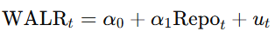
Second, a lagged regression model is estimated to capture delayed transmission from the repo rate to lending rates:
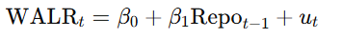
Third, a multivariate regression model incorporating both current and lagged repo rates is estimated to distinguish between immediate and delayed effects:
​ 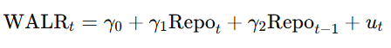
Finally, the transmission from lending rates to inflation is examined using a lagged regression model:
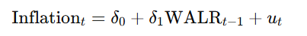

Hypothesis Testing
For each regression model, standard hypothesis tests are conducted to assess statistical significance. The null hypothesis in each case states that the relevant slope coefficient is equal to zero, implying no transmission effect. The alternative hypothesis states that the coefficient is statistically different from zero. Statistical significance is evaluated using t-tests and corresponding p-values at conventional significance levels (1%, 5%, and 10%)

Estimation Technique
All models are estimated using the Ordinary Least Squares (OLS) method. OLS is chosen due to its simplicity, interpretability, and widespread use in empirical monetary policy studies. Regression analysis, hypothesis testing, and residual diagnostics are implemented using the Data Analysis ToolPak in Microsoft Excel.

Forecasting and Scenario Analysis
Based on the estimated regression coefficients, short-term forecasts of WALR and inflation are generated. Forecasts are produced under the assumption of an unchanged policy repo rate, as well as under alternative monetary policy scenarios involving rate increases or decreases. Multi-step forecasts are generated recursively, using previously forecasted values for lagged variables. These forecasting exercises illustrate the potential future path of lending rates and inflation under different policy conditions.

Data Visualization
To support empirical findings, graphical techniques are employed, including line charts, scatter plots with trendlines, and actual-versus-fitted plots. These visualizations enhance interpretability by illustrating transmission dynamics, model fit, and forecast trajectories.

Limitations
Despite providing useful insights into the interest rate channel of monetary policy transmission in India, this study is subject to certain limitations. First, the econometric analysis relies on a relatively simple linear regression framework estimated using Ordinary Least Squares (OLS). While this approach allows for transparency and ease of interpretation, it may not fully capture the complex, nonlinear, and dynamic interactions among monetary policy variables, lending rates, and inflation. More advanced time-series techniques such as Vector Autoregression (VAR) or Error Correction Models (ECM) could provide a richer representation of transmission dynamics.
Second, the model includes a limited set of explanatory variables, focusing primarily on the repo rate and lending rates. Inflation in India is influenced by several additional factors such as supply-side shocks, food and fuel prices, fiscal policy measures, exchange rate movements, and global commodity price fluctuations. The exclusion of these variables may lead to omitted variable bias and reduces the explanatory power of the estimated inflation model.
Third, the study assumes a uniform transmission mechanism across the entire sample period. In reality, monetary transmission may vary across different phases of the business cycle, during periods of financial stress, or following regulatory changes such as external benchmarking of lending rates. Structural breaks and regime shifts are not explicitly accounted for in the analysis, which may affect the stability of estimated coefficients over time.
Finally, the forecasting exercise is based on the assumption of stable relationships between variables and unchanged policy behavior beyond the sample period. Such assumptions may not hold in the presence of unexpected macroeconomic shocks or changes in monetary policy strategy. Additionally, forecasts generated using Excel-based regression tools are illustrative in nature and should be interpreted as conditional projections rather than precise predictions.

Conceptual Paradigm
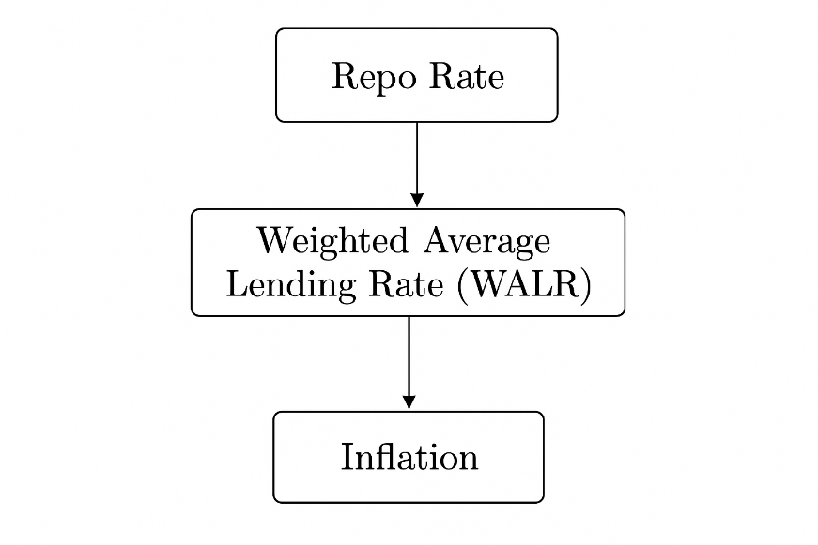

Data Visualization
Data visualization plays a crucial role in enhancing the interpretation and communication of econometric results by transforming numerical outputs into intuitive graphical representations. In this study, visualization techniques are used to complement regression analysis and to provide clear insights into the monetary policy transmission mechanism in India. By visually examining trends, relationships, and model outcomes, data visualization helps bridge the gap between statistical results and economic interpretation.

Trend Chart Policy Repo rate:

The policy repo rate chart illustrates the Reserve Bank of India's (RBI) primary monetary policy tool, showcasing distinct cyclical phases driven by the twin mandates of managing inflation and supporting economic growth. Starting from a relatively higher point (around 7.75% in early 2015), the rate generally eased downwards, reflecting a period of moderating inflation and the need to boost economic momentum.
This trend was abruptly punctuated by a sharp, deep cut to a historic low (4.00%) in early 2020 as an emergency response to the COVID-19 pandemic, where the focus was entirely on injecting liquidity and supporting recovery. This low-rate regime lasted until mid-2022, when global commodity price spikes and supply chain issues caused inflation to surge, forcing the RBI to pivot aggressively.
This resulted in a steep tightening cycle, rapidly raising the rate back up to a peak of 6.50% by early 2023. Following an extended 'pause' phase throughout 2023 and much of 2024 to allow previous hikes to anchor inflation, the chart now shows a significant easing cycle throughout 2025, with the rate being cut sequentially from 6.50% down to the current 5.25% (as of December 2025), signaling the RBI's renewed confidence in stable, lower inflation and its shift back to an accommodative stance to sustain economic growth.
.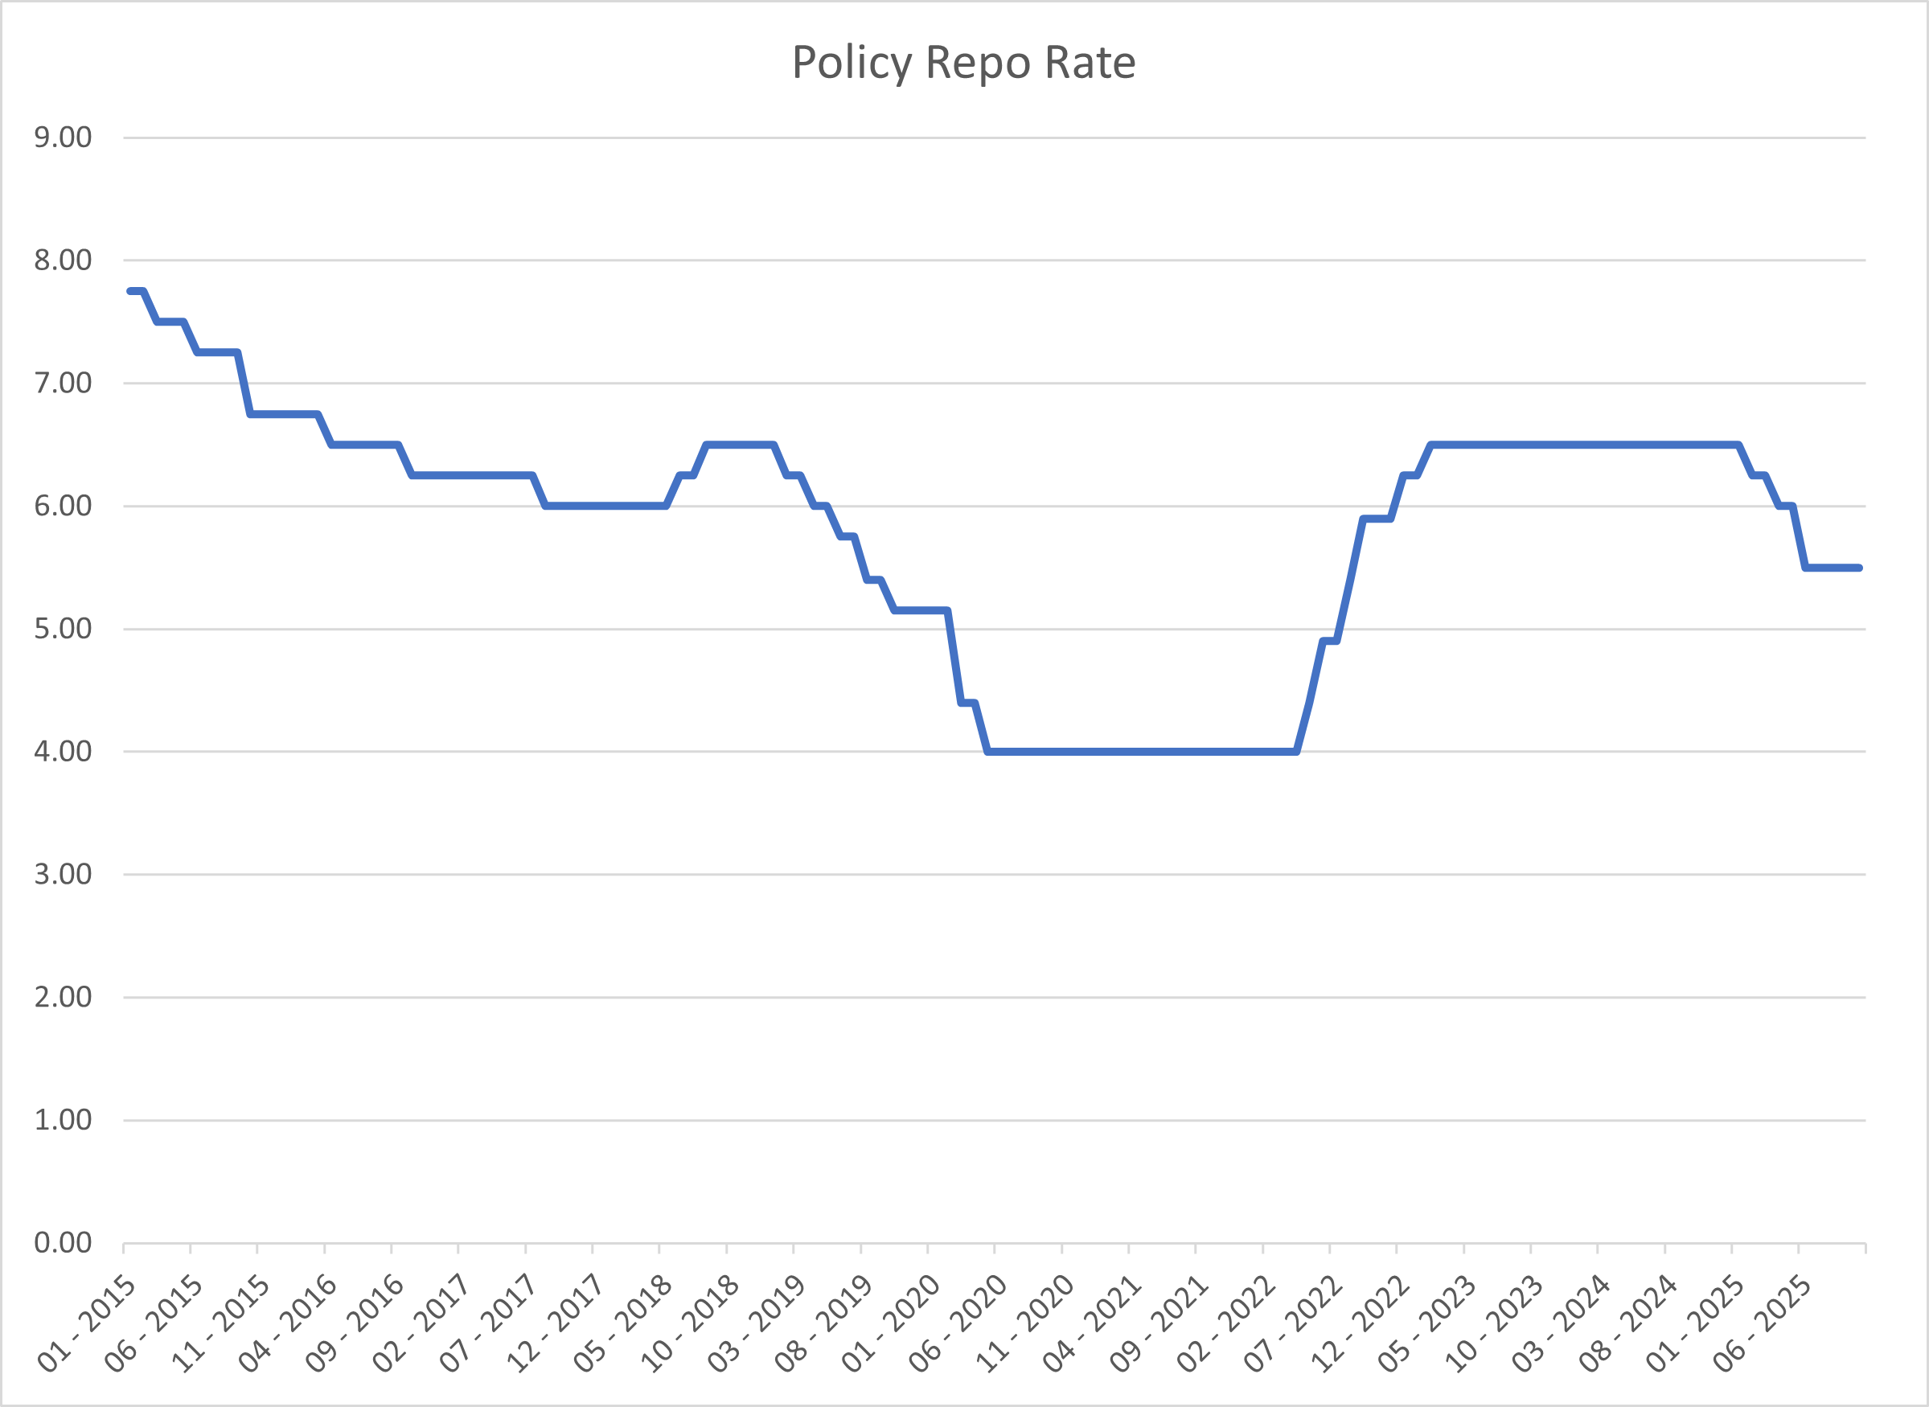

Trend Chart Weighted Average Lending Rate (WALR)

The Weighted Average Lending Rate (WALR) chart provides a visual confirmation of how monetary policy changes, driven by the Policy Repo Rate, are transmitted through the Indian banking system to impact the cost of borrowing. The period from 2015 to 2020 clearly shows the WALR trending downwards from approximately 8.0% towards 5.0%, reflecting the Reserve Bank of India's (RBI) general rate-cutting cycle aimed at stimulating a slowing economy. This easing culminated in a sharp, dramatic drop in the WALR to a historic low of around 3.4% during 2020-2021, directly following the RBI's aggressive, emergency Repo Rate cuts (to 4.00%) implemented to flood the economy with cheap credit and counteract the severe impact of the COVID-19 pandemic.
The subsequent phase, driven by inflationary pressures, saw a strong and rapid reversal in both policy and lending rates. Starting in mid-2022, the WALR surged aggressively from its low point to peak around 6.7% by mid-2023, tracking the RBI's steep and consecutive Repo Rate hikes designed to anchor inflation expectations. After a period of stability at this elevated level through much of 2024, the WALR chart concludes with a noticeable decline beginning in late 2024 and continuing through 2025, settling near 5.3% in early 2026. This final easing phase mirrors the RBI's decision to cut the Repo Rate (down to 5.25% by late 2025) as inflation moderated, signalling a shift back to supporting sustained economic growth by lowering the cost of credit.

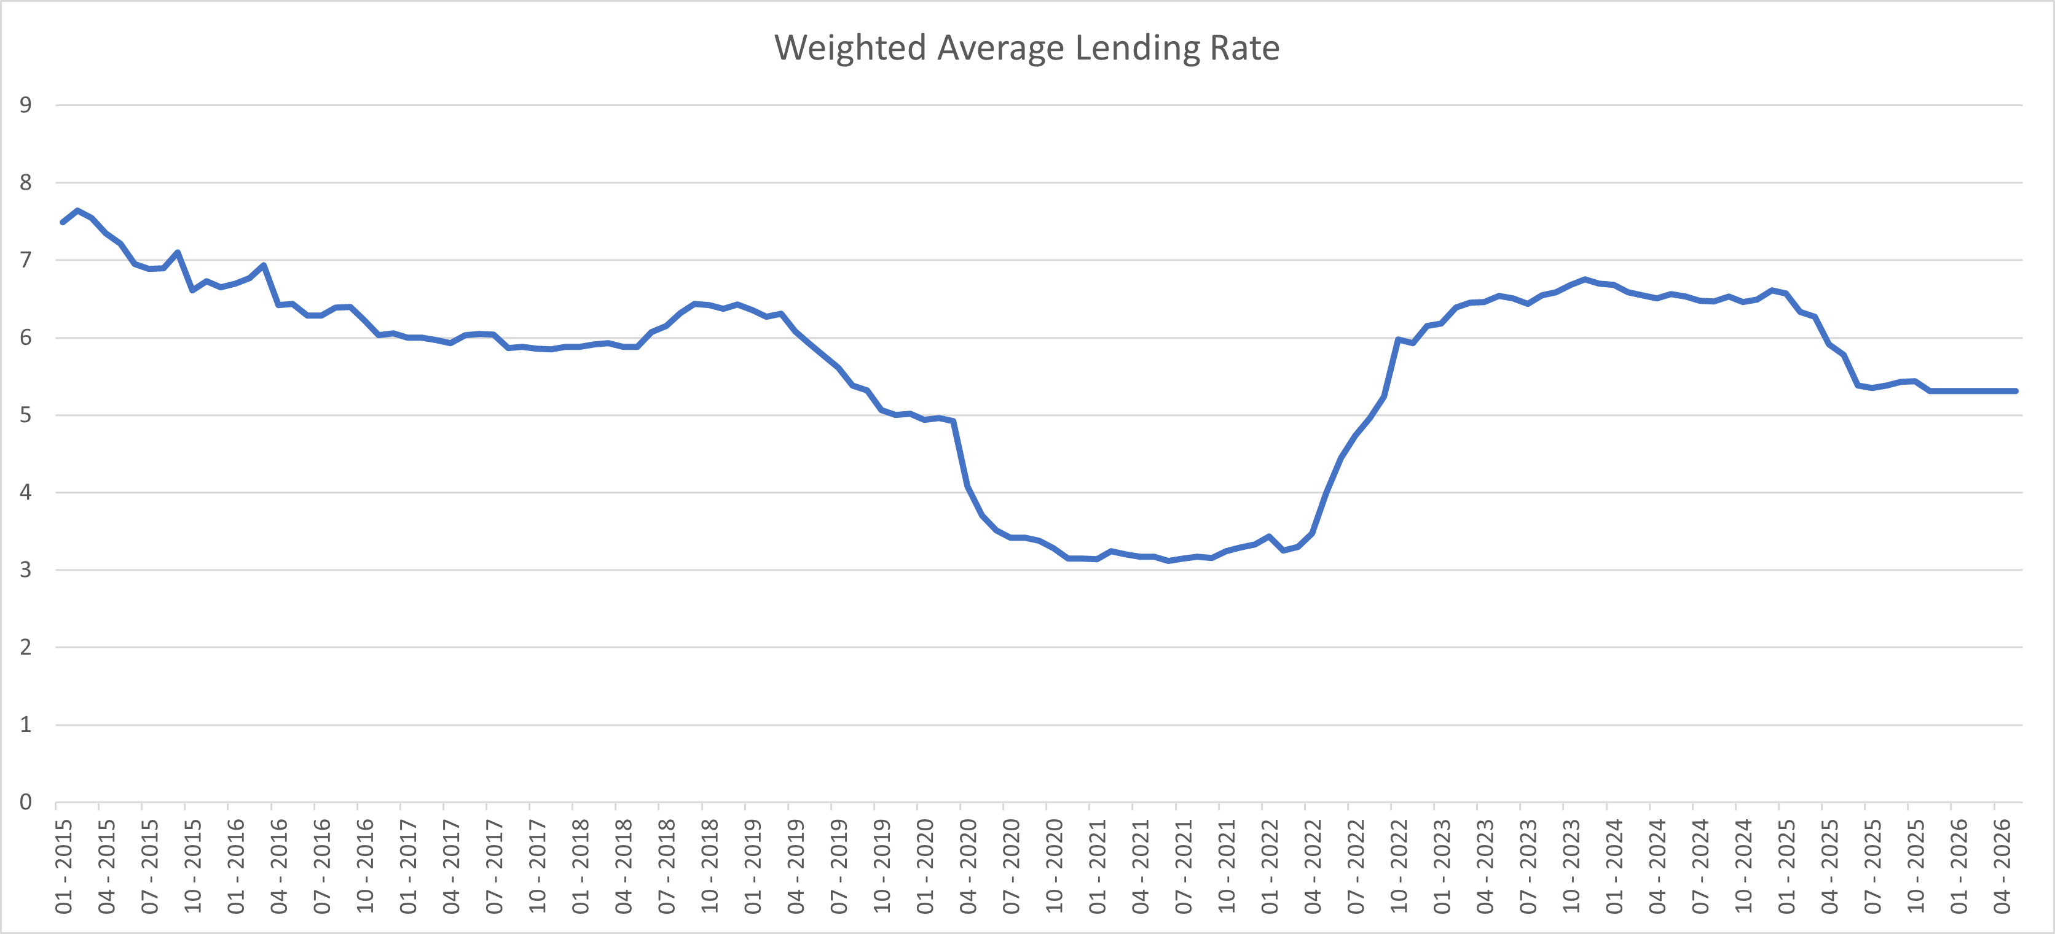

CPI Inflation Rate Chart
The CPI Inflation chart illustrates extreme volatility, particularly after 2019, reflecting various domestic and global shocks. From 2015 through 2019, the rate generally showed a degree of moderation and control. During this period, the rate mostly fluctuated within the RBI's target band (or slightly outside it), hovering generally between 3% and 6%. There was a dip to a low point around 1.5% in mid-2017, followed by a rise and then another decline to nearly 2.0% in mid-2019. This overall pattern gave the RBI space to implement an accommodative monetary policy, cutting the Policy Repo Rate to support economic growth, as seen in the corresponding Policy Repo Rate chart. However, this period of relative stability was short-lived as global events began to trigger massive price pressures.
The period from late 2019 onwards saw the CPI Inflation rate become extremely volatile and surge past the upper tolerance level of 6% multiple times. Inflation spiked above 7.0% around 2020 due to pandemic-induced supply disruptions and again, more severely, from late 2021 through mid-2023, reaching peaks close to 8.0%. This extended period of high inflation, driven largely by global commodity price surges (especially food and energy following geopolitical events), forced the RBI to abruptly reverse its monetary stance and aggressively hike the Policy Repo Rate. By late 2023 and 2024, inflation pressures began to ease, although the chart shows continued volatility. Critically, by the end of 2025, the chart depicts a sharp and encouraging decline, with the rate falling well below 2.0% and settling near 0.5% in the final months shown, suggesting a successful taming of price pressures which then enabled the central bank to pivot towards rate cuts.
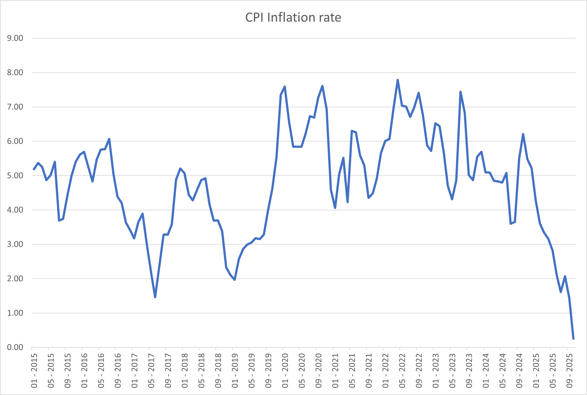

Weighted Average Lending Rate vs Repo rate

The combined chart of the Policy Repo Rate and the Weighted Average Lending Rate (WALR) offers a clear view of the monetary policy transmission mechanism over a decade. The prevailing trend from 2015 to early 2020 saw both rates trending generally downwards, confirming that the RBI’s rate cuts aimed at economic stimulus were effectively translating into a lower average cost of credit. Crucially, during the COVID-19 period (2020-2022), the Policy Repo Rate was held constant at its historic low of 4.00%, yet the WALR consistently dipped and remained significantly below this benchmark, falling to approximately 3.1%. This inversion highlights an aggressive push by the banking system to deploy surplus liquidity and lend at rates lower than the policy floor, a direct response to the economic crisis and a key policy objective to ensure continuous credit flow.
Following the initiation of the anti-inflation tightening cycle in mid-2022, both the Repo Rate and the WALR show a rapid, near-simultaneous ascent, demonstrating the increased efficiency of policy transmission, largely due to the mandating of External Benchmark Lending Rates (EBLR). The WALR closely tracked the Repo Rate's rise to its peak of 6.50%, even briefly surpassing it to reach approximately 6.8%, reflecting increased pricing by banks in a high-inflation environment. Finally, the easing cycle throughout 2025 sees the Policy Repo Rate dropping, with the WALR immediately following suit, settling near 5.4% as the Repo Rate falls to 5.50% by early 2026. The near-instantaneous movement of the WALR confirms that, at this monthly aggregation level, the monetary policy signal is being passed through to the cost of new credit with high efficiency, showing little effective lag.
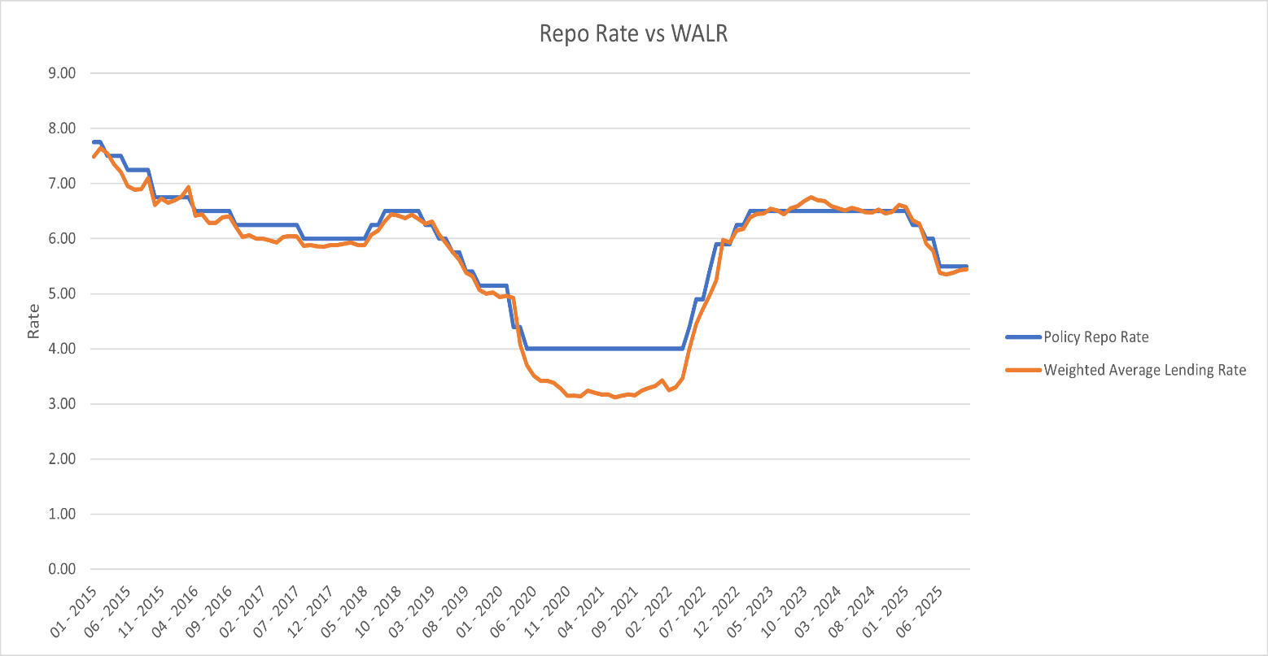
WALR(Lagged) vs CPI Inflation
The scatter plot analyzing the relationship between CPI Inflation Rate (X-axis) and the WALR (t-1) (Y-axis, or lagged Weighted Average Lending Rate) reveals that the cost of credit one period prior has a very weak and unreliable linear relationship with current inflation. The $R^2$ value of 0.1119 confirms this, indicating that only about 11% of the variation in the lagged lending rate can be explained by the current inflation rate. A visually apparent large horizontal cluster of points around a WALR of 3.0% to 3.5% corresponds to the 2020-2022 pandemic period. During this time, the WALR remained at historic lows despite inflation fluctuating widely between 3.5% and over 7.0%. This significant grouping illustrates that the WALR was overwhelmingly driven by the RBI's policy and liquidity management (maintaining the Policy Repo Rate at 4.00%) rather than a direct, market-driven response to the inflation rate itself.
The overall lack of a strong linear correlation suggests that the WALR is primarily influenced by the Policy Repo Rate, which is the central bank's reaction to inflation, rather than being directly correlated with the inflation rate itself. While the central bank tightens policy to curb inflation, the direct correlation between the market's average lending cost one month ago and the current price level is tenuous. The rest of the data points are scattered, confirming that the linkage is indirect and subject to numerous other economic variables, such as global commodity prices, supply-side factors, and the overall economic output gap, which have a much more immediate and stronger impact on CPI inflation than the lagged cost of bank credit.

Approach

The study adopts a systematic empirical approach beginning with data extraction and preparation, followed by econometric analysis, forecasting, and visualization. Monthly data on the policy repo rate, weighted average lending rate (WALR), and Consumer Price Index (CPI)–based inflation are extracted from official sources, including the Reserve Bank of India (RBI) and the Ministry of Statistics and Programme Implementation (MoSPI). Since some interest rate data are available at higher frequencies, daily observations are aggregated into monthly averages to ensure consistency across variables.
Data cleaning constitutes the second stage of the analysis. This involves checking for missing observations, aligning time periods across datasets, standardizing date formats, and ensuring uniform measurement units. Lagged variables are constructed after confirming chronological consistency to avoid look-ahead bias. Outliers and abnormal observations are examined through graphical inspection, and all transformations are documented to maintain transparency and reproducibility.
Following data preparation, exploratory data analysis and visualization are conducted to examine trends and co-movements among variables. The econometric analysis proceeds with the estimation of a sequence of Ordinary Least Squares (OLS) regression models, starting with simple regressions and extending to lagged and multivariate specifications to capture dynamic monetary transmission effects. Hypothesis testing is applied to assess statistical significance, after which the estimated models are used for short-term forecasting and scenario-based simulations. The findings are presented using clear and informative visualizations created in Microsoft Excel, ensuring that empirical results are both interpretable and policy-relevant.

DATABASE
• The database developed for this study is a monthly time-series dataset specifically constructed to analyze the interest rate channel of monetary policy transmission in India.
• Data are sourced exclusively from official and reliable institutions, primarily the Reserve Bank of India (RBI) for interest rate variables and the Ministry of Statistics and Programme Implementation (MoSPI) for inflation data, ensuring authenticity and accuracy.
• The key variables included in the database are:
- Policy Repo Rate, representing the monetary policy stance of the RBI.
- Weighted Average Lending Rate (WALR), capturing the average borrowing cost faced by households and firms.
- Consumer Price Index (CPI)–based Inflation (Base 2012 = 100), measuring changes in the general price level.
• Interest rate series originally available at a daily frequency were aggregated into monthly averages to maintain uniformity across variables and to align with the frequency of inflation data.
• The database incorporates constructed lag variables, including one-period lagged repo rate and one-period lagged WALR, to capture the delayed effects of monetary policy transmission.
• A comprehensive data cleaning process was undertaken, involving:
- Removal or correction of missing observations.
- Standardization of date formats.
- Verification of chronological consistency to avoid look-ahead bias.
- Visual inspection for outliers or abnormal observations.
• All variables were checked for consistency in measurement units and temporal alignment before inclusion in econometric models.
• The final dataset is organized in a tabular Excel format, where each row corresponds to a single month and each column represents a specific variable or transformation.
• The database is designed to be reproducible, transparent, and adaptable, allowing easy extension to include additional variables or longer time horizons.
• This database serves as the empirical foundation for regression analysis, hypothesis testing, forecasting exercises, and data visualization carried out in the study.

Regression Analysis
To empirically examine the interest rate channel of monetary policy transmission in India, a sequence of regression models is estimated using Ordinary Least Squares (OLS). Each regression is designed to capture a specific stage of the transmission process, moving from policy rates to lending rates and finally to inflation. The use of multiple models allows for a comprehensive understanding of both contemporaneous and lagged effects.

Repo Rate and WALR (Contemporaneous Model)
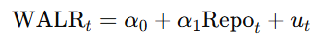
This model examines the immediate or contemporaneous impact of the policy repo rate on bank lending rates. The dependent variable, WALR, represents the average lending rate charged by banks, while the repo rate captures the stance of monetary policy. The coefficient α1\alpha_1α1​ measures the extent of interest rate pass-through from the policy rate to lending rates within the same period.
A positive and statistically significant α1​ indicates effective and rapid monetary transmission. This model is particularly useful for identifying whether banks respond promptly to changes in the policy rate, reflecting the strength of the interest rate channel in the short run.
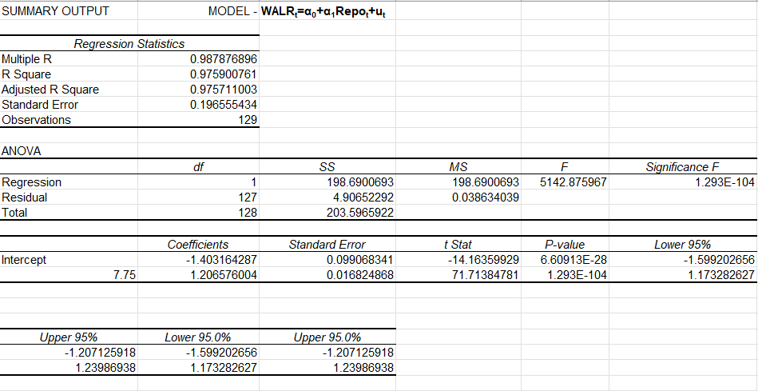
Null Hypothesis (H₀₂):
The lagged repo rate does not significantly affect the current Weighted Average Lending Rate.
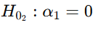
Alternative Hypothesis (H₁₂):
The lagged repo rate significantly affects the current Weighted Average Lending Rate.
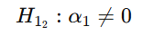

Key Points and Findings
1. Strong Relationship Between Repo Rate and WALR
The Multiple R value of 0.988 indicates an extremely strong positive linear relationship between the policy repo rate and the Weighted Average Lending Rate (WALR).
This confirms that changes in the repo rate are closely mirrored by movements in bank lending rates.

2. High Explanatory Power of the Model
The R² value of 0.976 implies that approximately 97.6% of the variation in WALR is explained by changes in the repo rate.
The Adjusted R² (0.976) being almost identical to R² suggests that the model is well specified and not overfitted.

3. Statistically Significant Model (Overall Fit)
The F-statistic (5142.88) is extremely high.
The corresponding Significance F (1.29 × 10⁻¹⁰⁴) is far below the 1% significance level.
This confirms that the model is statistically significant as a whole and that the repo rate is a meaningful predictor of WALR.

4. Significant Positive Pass-Through Coefficient
The estimated slope coefficient for the repo rate is 1.206.
This implies that a 1 percentage point increase in the repo rate leads to an average increase of about 1.21 percentage points in WALR.
The coefficient is highly statistically significant with a p-value of 1.29 × 10⁻¹⁰⁴, indicating very strong evidence against the null hypothesis of no effect.

5. Interpretation of the Intercept
The intercept value of –1.403 represents the theoretical level of WALR when the repo rate is zero.
While not economically meaningful in practice, the intercept is statistically significant and serves as a baseline adjustment factor in the model.

6. Precision of Estimates
The standard errors for both the intercept and the repo rate coefficient are very small, indicating precise parameter estimates.
The 95% confidence interval for the repo rate coefficient lies between 1.17 and 1.24, reinforcing the robustness of the pass-through effect.

7. Evidence of Efficient Monetary Transmission
The magnitude and significance of the repo rate coefficient suggest a strong and near-complete transmission of policy rate changes to lending rates.
This indicates that the interest rate channel of monetary policy in India is effective at the bank lending level.

8. Policy Implication
Since lending rates respond strongly to changes in the repo rate, monetary policy actions by the Reserve Bank of India are likely to influence borrowing costs in the economy.
This strengthens the central bank’s ability to manage demand conditions through interest rate adjustments.

Lagged Repo Rate and WALR (Delayed Transmission Model)
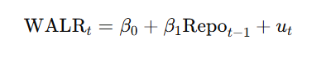
This model captures the delayed effect of monetary policy on lending rates by introducing a one-period lag of the repo rate. The coefficient β1\beta_1β1​ measures how past policy decisions influence current lending rates. This is important because banks often adjust lending rates gradually due to existing loan contracts, expectations about future policy changes, and balance sheet considerations.
A statistically significant β1​ provides evidence of persistence in monetary transmission and confirms that policy rate changes continue to affect lending rates beyond the period in which they are announced.
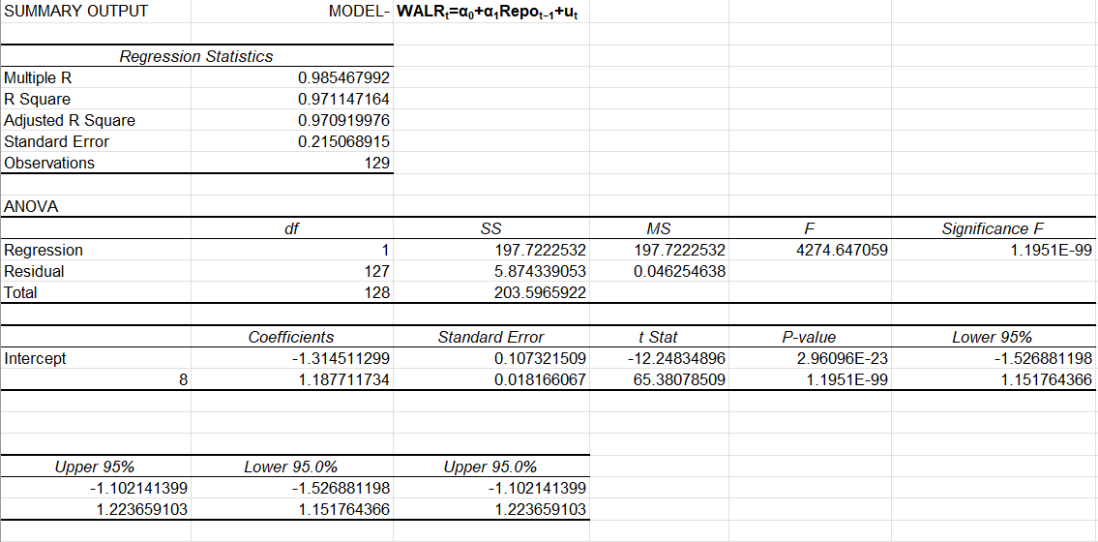
Null Hypothesis (H₀₂):
The lagged repo rate does not significantly affect the current Weighted Average Lending Rate.
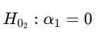
Alternative Hypothesis (H₁₂):
The lagged repo rate significantly affects the current Weighted Average Lending Rate.
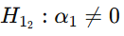

Key Points and Findings

1. Strong Lagged Relationship Between Repo Rate and WALR
The Multiple R value of 0.985 indicates a very strong positive relationship between the lagged repo rate and the current WALR.
This confirms that changes in the repo rate do not only affect lending rates contemporaneously but also carry over into subsequent periods.

2. High Explanatory Power Despite Lag
The R² value of 0.971 suggests that about 97.1% of the variation in WALR is explained by the repo rate of the previous period.
The slight reduction in R² compared to the contemporaneous model indicates a minor decay in explanatory power, but the relationship remains extremely strong.

3. Statistical Significance of the Model
The F-statistic (4274.65) is very large, indicating strong overall model fit.
The Significance F (1.20 × 10⁻⁹⁹) is far below conventional significance levels, confirming that the lagged repo rate is a statistically significant determinant of WALR.

4. Magnitude of Lagged Pass-Through
The coefficient on Repoₜ₋₁ is 1.188, implying that a 1 percentage point increase in the repo rate in the previous period leads to an increase of about 1.19 percentage points in WALR in the current period.
This suggests a high degree of persistence in monetary policy transmission.

5. Precision and Reliability of Estimates
The standard error of the lagged repo rate coefficient is very small (0.018), reflecting precise estimation.
The 95% confidence interval for the coefficient (1.15 to 1.22) excludes zero by a wide margin, reinforcing robustness.

6. Interpretation of the Intercept
The intercept value (–1.315) represents the estimated WALR when the lagged repo rate is zero.
While not economically interpretable in practice, it helps adjust the regression line and is statistically significant.

7. Evidence of Delayed Transmission Mechanism
The significance of the lagged repo rate indicates that banks adjust lending rates with a time lag, consistent with operational rigidities such as loan repricing cycles and contract structures.
This aligns with theoretical expectations of gradual monetary transmission.

8. Comparison with Contemporaneous Model
Compared to the contemporaneous model, the lagged model shows:
Slightly lower R²
Similar coefficient magnitude
Continued high statistical significance
This implies that repo rate changes affect WALR both immediately and with a lag, suggesting a mixed transmission pattern.

9. Policy Implications
The presence of a strong lagged effect suggests that monetary policy actions have persistent effects on lending rates.
Policymakers should account for delayed transmission when evaluating the impact of interest rate decisions on credit conditions.

Current and Lagged Repo Rates with WALR (Dynamic Model) 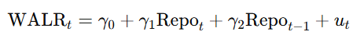
This model integrates both contemporaneous and lagged repo rates to analyze the dynamic adjustment process of lending rates. The coefficient γ1 ​ captures the immediate response of WALR to changes in the repo rate, while γ2 measures the delayed adjustment effect.
By including both variables, the model allows for a more realistic representation of monetary transmission, where banks respond quickly to policy signals but also continue adjusting rates over subsequent periods. The joint significance of both coefficients indicates that monetary policy transmission operates through both immediate and lagged channels.
Null Hypothesis (H₀₃):
Current and lagged repo rates jointly have no significant effect on WALR.
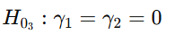
Alternative Hypothesis (H₁₃):
At least one of the current or lagged repo rate coefficients significantly affects WALR.
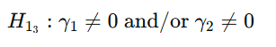

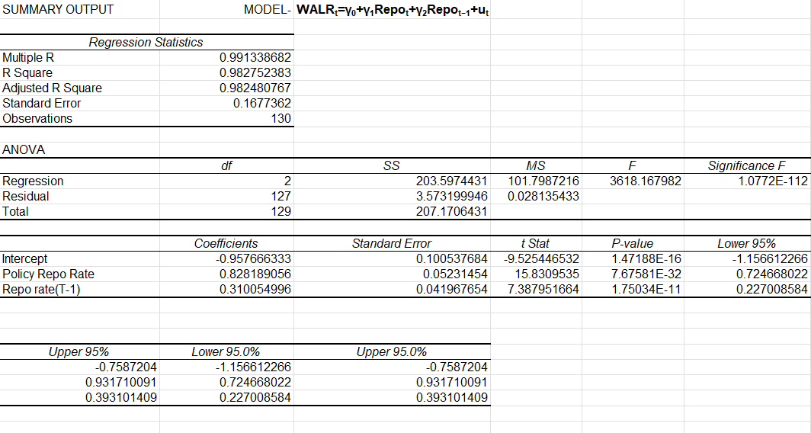

Key Points and Findings

1. Excellent Overall Model Fit
The Multiple R value of 0.991 indicates an exceptionally strong relationship between WALR and the explanatory variables.
The R² value of 0.983 implies that 98.3% of the variation in WALR is jointly explained by the current and lagged repo rates.
The Adjusted R² (0.982) remains very high, confirming that adding the lagged repo rate improves explanatory power without overfitting.

2. Strong Statistical Significance of the Model
The F-statistic (3618.17) is extremely large.
The corresponding Significance F (1.08 × 10⁻¹¹²) confirms that the model is statistically significant at all conventional levels.
This validates the joint relevance of contemporaneous and lagged repo rates in explaining WALR.

3. Contemporaneous Pass-Through Effect
The coefficient on the current repo rate (γ₁ = 0.828) is positive and highly significant (p-value ≈ 7.68 × 10⁻³²).
This implies that a 1 percentage point increase in the repo rate leads to an immediate increase of about 0.83 percentage points in WALR within the same period.
The confidence interval (0.72 to 0.93) indicates a robust and precisely estimated effect.

4. Lagged Pass-Through Effect
The coefficient on the lagged repo rate (γ₂ = 0.310) is also positive and statistically significant (p-value ≈ 1.75 × 10⁻¹¹).
This suggests that repo rate changes continue to influence lending rates even after one period, reflecting partial adjustment behavior by banks.

5. Long-Run Pass-Through Magnitude
The long-run (cumulative) pass-through is given by the sum of coefficients:
This indicates that a 1 percentage point increase in the repo rate ultimately raises WALR by about 1.14 percentage points, once both immediate and delayed effects are accounted for.

6. Evidence of Gradual Adjustment Mechanism
The presence of both significant contemporaneous and lagged effects implies that lending rates adjust gradually rather than instantaneously.
This behavior is consistent with institutional features such as loan repricing cycles, customer contracts, and administrative rigidities in the banking system.

7. Interpretation of the Intercept
The intercept (–0.958) represents the theoretical WALR when both current and lagged repo rates are zero.
While not economically meaningful in practice, it serves as a baseline control term in the regression.

8. Improved Performance Over Single-Variable Models
Compared to models using only Repoₜ or Repoₜ₋₁, this distributed lag model:
Has higher R² and Adjusted R²
Captures both immediate and delayed effects
Provides a more realistic representation of monetary transmission
This confirms the superiority of the model in explaining WALR dynamics.

9. Policy Implications
Monetary policy actions by the RBI influence lending rates both immediately and over subsequent periods.
Policymakers should consider these dynamic effects when assessing the timing and strength of interest rate transmission.

Lagged WALR and Inflation (Price Transmission Model)
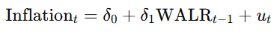
This model examines the final stage of the transmission mechanism by analyzing the impact of lending rates on inflation. Inflation is the dependent variable, while lagged WALR captures borrowing costs faced by households and firms in the previous period. The lag structure reflects the fact that changes in interest rates affect demand and prices with a delay.
A negative and statistically significant δ1\delta_1δ1​ supports the theoretical prediction that higher lending rates reduce inflation by curbing aggregate demand. Although the explanatory power of this model is relatively modest, this is expected in an economy where inflation is influenced by multiple non-monetary factors.
Null Hypothesis (H₀₄):
Lagged Weighted Average Lending Rate has no significant effect on inflation.
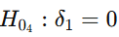
Alternative Hypothesis (H₁₄):
Lagged Weighted Average Lending Rate has a significant effect on inflation.
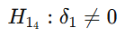

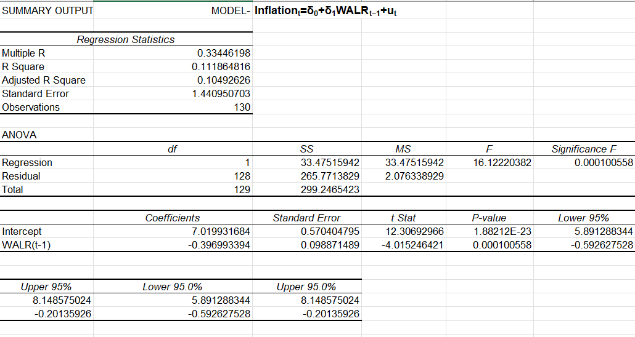

Key Points and Findings
1. Existence of a Statistically Significant Relationship
The F-statistic (16.12) with a Significance F of 0.00010 indicates that the model is statistically significant.
This confirms that the lagged WALR has a meaningful explanatory relationship with inflation, even though the strength is moderate.

2. Limited Explanatory Power
The R² value of 0.112 suggests that approximately 11.2% of the variation in inflation is explained by changes in WALR in the previous period.
The Adjusted R² (0.105) is only slightly lower, indicating that the model is not overfitted but captures a limited portion of inflation dynamics.

3. Negative Effect of Lagged Lending Rates on Inflation
The coefficient on WALRₜ₋₁ is –0.397, which is statistically significant at the 1% level.
This implies that a 1 percentage point increase in lending rates in the previous period reduces inflation by about 0.40 percentage points in the current period.
This negative relationship is consistent with contractionary monetary policy effects reducing aggregate demand.

4. Statistical Significance of the Coefficient
The t-statistic (–4.02) and p-value (0.00010) strongly reject the null hypothesis that the coefficient on WALRₜ₋₁ is zero.
The 95% confidence interval (–0.59 to –0.20) excludes zero, reinforcing robustness.

5. Interpretation of the Intercept
The intercept value (7.02) represents the estimated inflation rate when WALRₜ₋₁ is zero.
While not economically realistic, the intercept reflects underlying inflationary pressures unrelated to lending rates.

6. Evidence of Delayed Monetary Policy Impact on Inflation
The significance of WALRₜ₋₁ (rather than WALRₜ) suggests that monetary policy affects inflation with a time lag.
This aligns with monetary theory, which predicts that interest rate changes influence inflation gradually through consumption and investment channels.

7. Role of Non-Monetary Factors
The low R² highlights that inflation in India is influenced by several non-monetary factors such as:
Supply-side shocks (food and fuel prices)
Global commodity prices
Fiscal policy and administered prices
Lending rates form only one component of the broader inflation process.

8. Policy Interpretation
The results indicate that tightening lending conditions can help moderate inflation, but interest rate policy alone is insufficient to fully control inflation.
Coordinated policy measures addressing supply constraints are necessary for effective inflation management.

9. Completion of the Transmission Chain
Combined with earlier results, this model completes the transmission mechanism:
Repo Rate → WALR → Inflation
While pass-through from repo to WALR is strong, the effect on inflation is weaker and delayed, reflecting real-world complexities.

Overall Results of the Study
The empirical analysis conducted in this study provides strong evidence in support of an effective monetary policy transmission mechanism in India through the interest rate channel. The regression results consistently demonstrate that changes in the policy repo rate are significantly transmitted to bank lending rates, both contemporaneously and with a lag, indicating a robust and dynamic pass-through process.
The contemporaneous regression model reveals that the Weighted Average Lending Rate (WALR) responds immediately to changes in the repo rate, reflecting prompt adjustment by commercial banks to monetary policy signals. The lagged and distributed lag models further show that repo rate changes continue to influence lending rates over subsequent periods, highlighting the presence of gradual adjustment and persistence in lending rate movements. Among all specifications, the distributed lag model provides the best explanatory power, suggesting that lending rates are shaped by both current and past monetary policy actions.
The inflation regression establishes a statistically significant negative relationship between lagged lending rates and inflation, confirming that higher borrowing costs contribute to moderating price pressures over time. Although the explanatory power of this model is relatively lower, the results align with economic theory, indicating that inflation dynamics are influenced by multiple factors beyond interest rates, including supply-side conditions and demand shocks.
Overall, the findings validate the effectiveness of the interest rate channel as a key conduit of monetary policy transmission in India. The study confirms that policy rate adjustments by the Reserve Bank of India are successfully transmitted to lending rates and subsequently influence inflation with a time lag. These results reinforce the relevance of conventional monetary policy tools in achieving macroeconomic stability, while also underscoring the importance of considering lags and dynamic effects in policy analysis.

Limitations of the Study
- The study considers only a limited number of variables—repo rate, Weighted Average Lending Rate (WALR), and inflation—while other macroeconomic factors such as exchange rate, money supply, fiscal policy, and global commodity prices are excluded.
- The analysis is based on aggregate monthly data, which may conceal sector-wise or bank-wise differences in interest rate pass-through behaviour.
- The regression models used are linear in nature, which limits the ability to capture non-linear or asymmetric responses of lending rates and inflation to policy changes.
- Possible structural breaks arising from major economic events (such as policy regime shifts or the COVID-19 pandemic) are not explicitly modeled.
- The forecasting exercise is restricted to a short time horizon due to the unavailability of future values of explanatory variables.
- The study assumes ceteris paribus conditions, which may not fully hold in real-world macroeconomic environments.

Future Scope of the Study
- Future research may include additional macroeconomic variables such as GDP growth, money supply, exchange rate, crude oil prices, and fiscal deficit to improve model robustness.
- Advanced econometric techniques like VAR, VECM, ARDL, and Granger causality tests can be employed to study dynamic interactions and long-run relationships.
- The analysis can be extended using bank-level or sector-specific data to examine heterogeneity in interest rate transmission across different financial institutions.
- High-frequency data (weekly or daily) may be used to capture short-term monetary policy effects more accurately.
- Future studies can incorporate non-linear models to examine asymmetric responses during tightening and easing phases of monetary policy.
- Forecasting accuracy can be improved by applying scenario-based simulations or machine learning techniques.

Conclusion
The present study set out to examine the effectiveness of monetary policy transmission in India through the interest rate channel using regression analysis and data visualization techniques in Excel. By analyzing the relationship between the policy repo rate, Weighted Average Lending Rate (WALR), and inflation, the study provides empirical evidence on how monetary policy actions are transmitted to the real economy.
The regression results clearly demonstrate that changes in the repo rate are significantly and positively transmitted to bank lending rates, both contemporaneously and with a lag. This indicates a strong and efficient pass-through mechanism, where banks adjust lending rates promptly in response to monetary policy signals from the Reserve Bank of India. The distributed lag model further highlights that the impact of monetary policy persists over time, reflecting gradual adjustment behavior within the banking system.
The analysis also reveals that lending rates play a meaningful role in influencing inflation dynamics. The negative and statistically significant relationship between lagged WALR and inflation confirms that higher borrowing costs help moderate price pressures, although the magnitude of this effect is relatively modest. This suggests that while interest rates are an important policy tool, inflation in India is also driven by several non-monetary factors.

Overall, the findings validate the effectiveness of the interest rate channel as a key component of India’s monetary policy framework. The study underscores the relevance of conventional monetary policy instruments in achieving macroeconomic stability and highlights the importance of accounting for time lags in policy transmission. Despite certain limitations, the research contributes to a clearer understanding of monetary transmission mechanisms and provides a foundation for more advanced econometric analysis in future studies.

Appendix

DATASETS
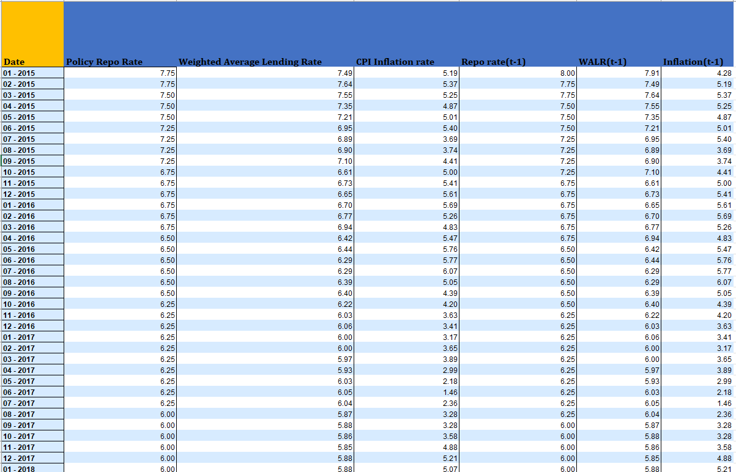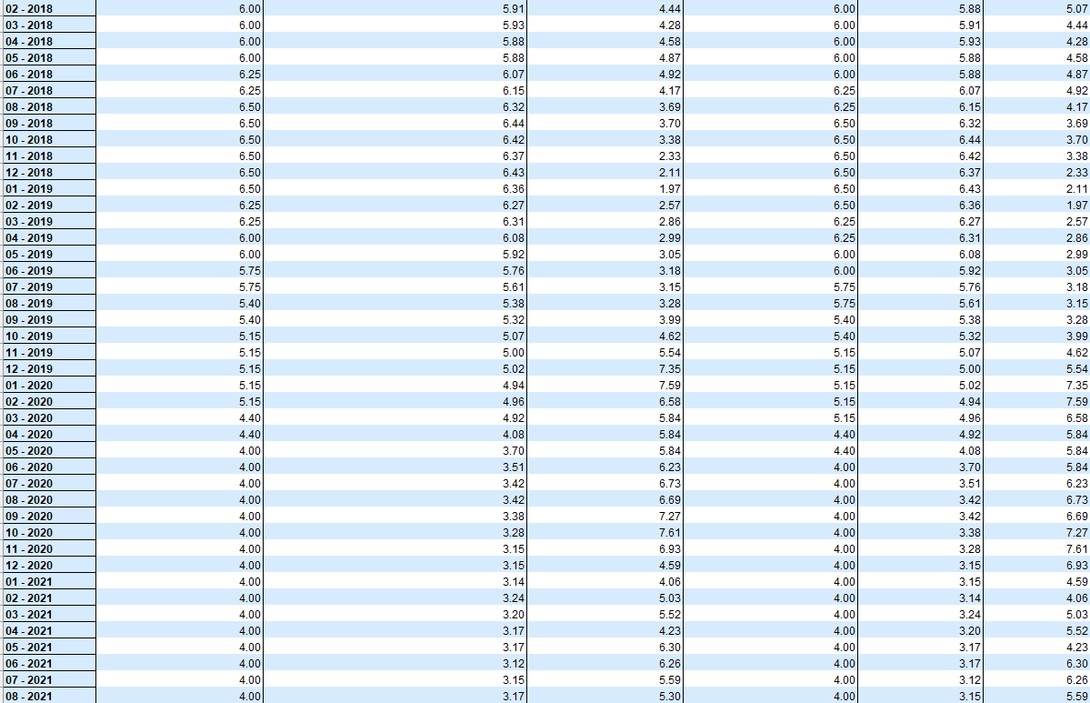

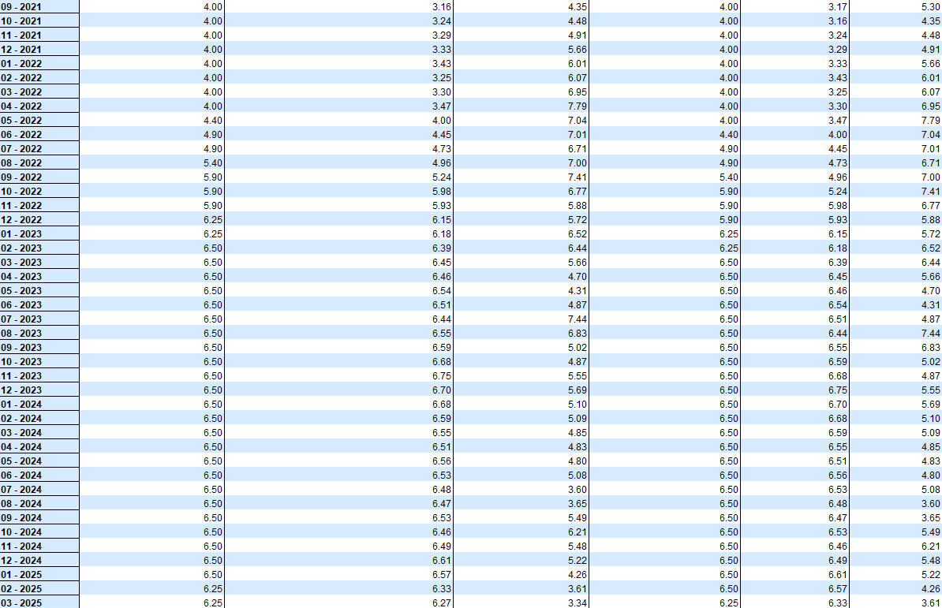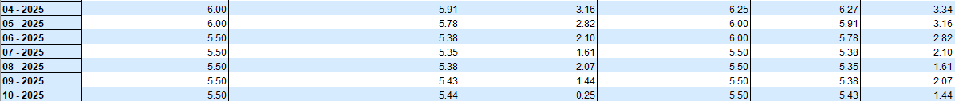
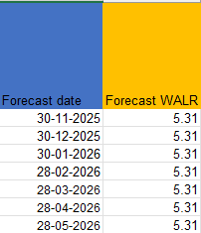

Bibliography

Official Data Sources (for Data Collection)
Reserve Bank of India (RBI)
Database on Indian Economy (DBIE) — Repo Rate, WALR, MCLR, etc.
https://dbie.rbi.org.in/
Ministry of Statistics & Programme Implementation (MoSPI)
Consumer Price Index (CPI) — Base 2012 = 100
https://mospi.gov.in/
Books
“Mishkin, Frederic S. (2015). The Economics of Money, Banking, and Financial Markets.”
“Gujarati, Damodar N., & Porter, Dawn C. (2020). Basic Econometrics.”

